Things you shouldn’t miss in Hungary.

Homepage | Form

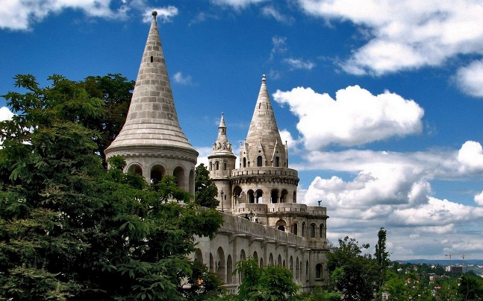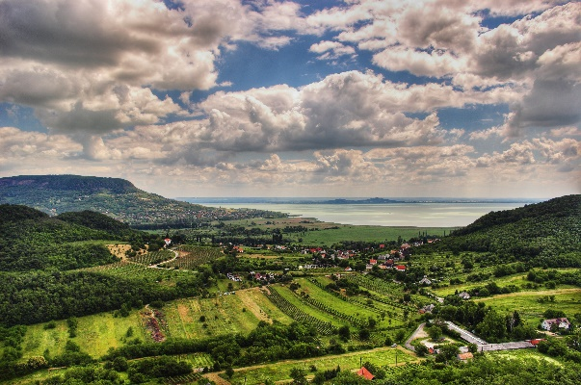

About the country:

Nestled in Central Europe, Hungary is a captivating blend of history, culture, and natural beauty. Explore Budapest’s charming streets and iconic landmarks. Venture beyond the city to discover rolling hills, vineyards and the tranquil shores of Balaton Lake. With its warm hospitality and diverse attractions, Hungary promises unforgettable experiences for every traveler.

Badacsonytomaj city Fisherman’s Bastion

The Parliament Chain Bridge

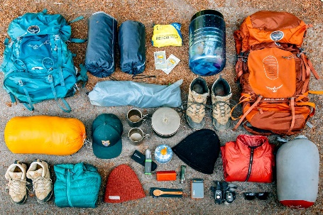

# How to prepare yourself?

Firstly, familiarize your self with Hungarian customs and you might learn a few basic Hungarian phrases to communicate with locals. Pack appropriate clothing for the season, as Hungary experiences distinct seasons with hot summers and cold winters. Don’t forget to bring comfortable walking shoes for exploring the city streets and countryside along with the hiking equipment like a tent, boots and many other equipment.

# A close-up of a white background



You can also download these two applications “Természetjáró” and “BudapestGo” to make your life easier when going around Hungary. The first application it helps you with finding the best routs for different hikes and it tells you the difficulty of each mountain and hill. On the other hand the second app is to help you with buying tickets for buses and other transportations easily online.

Természetjáró

A purple circle with white circle and white circle with white circle and white circle with white circle with white circle with white circle with white circle with white circle with white circle with white circle with white circle
[Link](https://apps.apple.com/hu/app/term%C3%A9szetj%C3%A1r%C3%B3-a-t%C3%BAratervez%C5%91/id1428702370) for apple phones | [Link](https://play.google.com/store/apps/details?id=com.outdooractive.mtsz&pli=1) for android phones

[Link](https://apps.apple.com/hu/app/budapestgo/id916193835) for apple phones | [Link](https://play.google.com/store/apps/details?id=hu.webvalto.bkkfutar) for android phones

# [One Day in Budapest - Travel Guide](https://www.youtube.com/embed/WClSJZGn9Tc?feature=oembed)Budapest, Capital of Hungary

Budapest is a city of captivating contrasts. Divided by the majestic Danube River, it seamlessly blends history, culture and modernity. On one side, Buda's ancient hills boast the iconic Buda Castle and Fisherman's Bastion, offering breathtaking views of the city. On the opposite bank, Pest's lively streets are adorned with grand boulevards, vibrant markets, and stunning architectural marvels like the Hungarian Parliament Building . [Read More](https://www.bing.com/ck/a?!&&p=843c6a80be3a25f7JmltdHM9MTcxMDYzMzYwMCZpZ3VpZD0xZDg3NGE5OC1lNmIyLTZlY2QtMzdkMC01OTAxZTcxYjZmZmMmaW5zaWQ9NTI0Mw&ptn=3&ver=2&hsh=3&fclid=1d874a98-e6b2-6ecd-37d0-5901e71b6ffc&psq=budapest&u=a1aHR0cHM6Ly9lbi53aWtpcGVkaWEub3JnL3dpa2kvQnVkYXBlc3Q&ntb=1)

And here are some stuff you can do in Budapest:

## Restaurants :

-Kelvin Kebab:



Whether you're craving a hearty meal after a day of exploration or seeking a quick bite on the go, Kelvin Kebab invites guests to savor the authentic taste of Turkish cuisine in the vibrant setting of Hungary's capital city. For the menu [Read More](https://www.bing.com/aclick?ld=e8ZvldSg2AwMDx4qLOx-_WCjVUCUw-J96neSOlxN-Yr5e8w6awDuNdMtmpNiqGhJGuVl3HCL2R6mZfwRtW3mhno9GGyb7ir2uQIyOitTpMJ9q5AVtXmxqs4u15T0H9Ta56396rgyOxSid3GyKaoQQ96UNq8zyn-_QU8787UK8Xk3DGv4SjTLh7KGffRWC0N1NoQ8KAYA&u=&rlid=a2dd3befe2931faf383f5e189c3faf31&ntb=1)

#### A large ornate building with gold ceiling and chandeliers-New York Café:

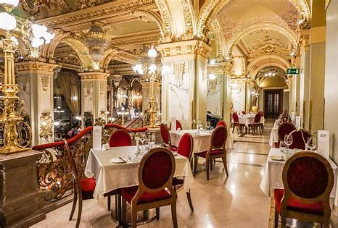

The New York Café in Budapest is a historic gem renowned for its grandeur and cultural significance. Located in the Boscolo Budapest Hotel, this café has a rich history dating back to the late 19th century when it was a hub for artists, writers, and intellectuals, earning it the nickname "the most beautiful café in the world." For more information [Read More](https://newyorkcafe.hu/en/)

#### A plate of rice with chicken-Zaiqa restaurant



Zaiqa Restaurant in Budapest offers a tantalizing journey into the flavors of Pakistani and Indian cuisine. Situated in the heart of the city, this culinary gem invites diners to savor authentic dishes crafted with care and expertise. From aromatic biryanis to flavorful curries and tandoori specialties, Zaiqa delights the palate with a diverse array of traditional delicacies. For the menu [Read More](https://www.bing.com/ck/a?!&&p=d0f5b8a8836e013cJmltdHM9MTcxMDYzMzYwMCZpZ3VpZD0xZDg3NGE5OC1lNmIyLTZlY2QtMzdkMC01OTAxZTcxYjZmZmMmaW5zaWQ9NTIxNw&ptn=3&ver=2&hsh=3&fclid=1d874a98-e6b2-6ecd-37d0-5901e71b6ffc&psq=zaiqa+restaurant&u=a1aHR0cHM6Ly93b2x0LmNvbS9lbi9odW4vYnVkYXBlc3QvcmVzdGF1cmFudC96YWlxYS1wYWtpc3p0YW5pLWZlcmVuYy1rcnQ&ntb=1)

## Entertainment:

#### A group of people at a barA crowd of people at a concert Description automatically generated-instant fogas:

Instant Fogas Club in Hungary is a vibrant nightlife destination located in the heart of Budapest. Comprising multiple bars, dance floors, and unique themed rooms, it offers an eclectic experience for partygoers. From electronic beats to live music performances, Instant Fogas Club hosts a diverse range of events, catering to various musical tastes. The venue's quirky decor and lively atmosphere create an unforgettable setting for socializing and dancing the night away. For more info [Read More](https://www.bing.com/ck/a?!&&p=7a2f40a90ebab26eJmltdHM9MTcxMDcyMDAwMCZpZ3VpZD0xZDg3NGE5OC1lNmIyLTZlY2QtMzdkMC01OTAxZTcxYjZmZmMmaW5zaWQ9NTIxMw&ptn=3&ver=2&hsh=3&fclid=1d874a98-e6b2-6ecd-37d0-5901e71b6ffc&psq=instant+fogas&u=a1aHR0cHM6Ly9pbnN0YW50LWZvZ2FzLmNvbS8&ntb=1)

*-Buda Castle:*

Buda Castle, situated atop the historic Castle Hill in Budapest, Hungary, is an iconic symbol of the city's rich history and architectural grandeur. This majestic palace complex has stood for centuries, witnessing the ebb and flow of Budapest's fortunes. Originally built in the 13th century, it has been reconstructed and expanded over the years, blending various architectural styles, including Gothic, Renaissance, and Baroque. Today, Buda Castle houses several museums, including the Hungarian National Gallery and the Budapest History Museum, showcasing the country's art and history. [Read More](https://www.bing.com/ck/a?!&&p=772d6a66e0aba3beJmltdHM9MTcxMDcyMDAwMCZpZ3VpZD0xZDg3NGE5OC1lNmIyLTZlY2QtMzdkMC01OTAxZTcxYjZmZmMmaW5zaWQ9NTI2Ng&ptn=3&ver=2&hsh=3&fclid=1d874a98-e6b2-6ecd-37d0-5901e71b6ffc&psq=buad+castle&u=a1aHR0cHM6Ly9lbi53aWtpcGVkaWEub3JnL3dpa2kvQnVkYV9DYXN0bGU&ntb=1)

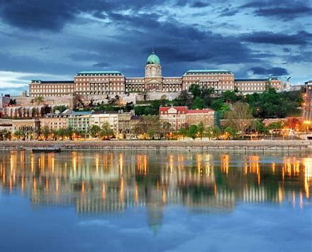

#### ­-Citadella:

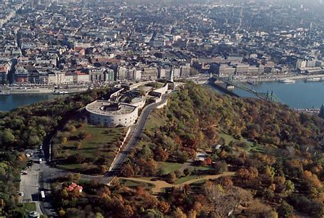

Originally built in the 19th century by the Habsburgs, it served as a fortress to assert control over the city. Today, it offers panoramic views of the stunning Hungarian capital, including the Danube River, Parliament Building, and iconic bridges. Visitors can explore the Citadel's historic walls, soak in breathtaking vistas, and contemplate Hungary's tumultuous past. [Read More](https://www.bing.com/ck/a?!&&p=f2b30c19bdf8db26JmltdHM9MTcxMDcyMDAwMCZpZ3VpZD0xZDg3NGE5OC1lNmIyLTZlY2QtMzdkMC01OTAxZTcxYjZmZmMmaW5zaWQ9NTIxOA&ptn=3&ver=2&hsh=3&fclid=1d874a98-e6b2-6ecd-37d0-5901e71b6ffc&psq=citadel+budapest&u=a1aHR0cHM6Ly9lbi53aWtpcGVkaWEub3JnL3dpa2kvQ2l0YWRlbGxh&ntb=1)

## Hiking:

#### -Normafa:

|  |  |
| --- | --- |
| **Name** | **Hiking Distance (in km)** |
| **Normafa** | **7.8** |
| **Hármashatár-hegy** | **10.2** |
| **Szép Kilátás** | **7.4** |

Nestled amidst lush forests, Normafa offers breathtaking panoramic views of the city and the surrounding countryside. It serves as a beloved destination for locals and tourists alike, providing ample opportunities for hiking, picnicking, and outdoor relaxation.

#### Three border mountain Budapest (Hármashatár-hegy):

it marks the meeting point of three historic regions: Buda, Pest, and Óbuda. Situated in the Buda Hills, this scenic area offers picturesque hiking trails and breathtaking views of the city below. The summit is adorned with a lookout tower offering panoramic vistas of Budapest and its surrounding countryside.

#### Szép Kilátás :

Szép Kilátás, meaning "Beautiful View" in Hungarian, is a picturesque viewpoint located in the Buda Hills near Budapest. it a popular destination for locals and tourists seeking relaxation and natural beauty. Whether admiring the sunset, enjoying a leisurely hike, or simply taking in the breathtaking scenery, Szép Kilátás is a must-visit destination for those exploring the enchanting landscapes of Hungary.

## Balaton Lake(Hungarian Sea)

[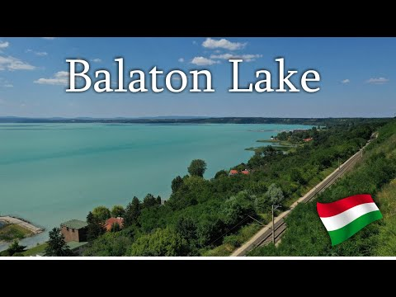](https://www.youtube.com/embed/FsNuSlPjOD4?feature=oembed)

Lake Balaton, often referred to as the "Hungarian Sea," is the largest freshwater lake in Central Europe. Visitors can explore historic towns such as Keszthely and Tihany, indulge in delicious local cuisine, or simply unwind on the sandy beaches. Whether you're seeking adventure or tranquility, Lake Balaton promises an unforgettable experience in the heart of Hungary's natural beauty.

There is a lot of cities around Balaton Lake so let me tell you about the most beautiful ones:

- Heviz, Western Transdanubia

-Siofok, Southern Transdanubia

-Badacsonytomaj

#### A building with a tower on top of a body of water- Heviz, Western Transdanubia:

It is renowned for its thermal lake, one of the largest natural hot water lakes in the world. Surrounded by lush greenery, this geothermal wonder remains warm throughout the year, offering therapeutic benefits to visitors seeking relaxation and rejuvenation. With its tranquil ambiance and healing properties, Hévíz promises a serene retreat amidst the picturesque landscapes of Western Transdanubia.

#### -Tihany:

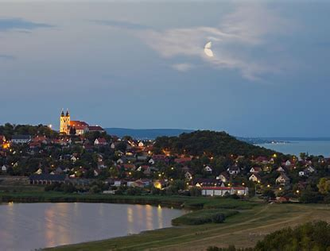

Tihany also offers opportunities for outdoor activities such as hiking, cycling, and water sports, making it a popular destination for nature lovers and adventure enthusiasts. With its blend of history, scenery, and recreational opportunities, Tihany offers a memorable experience for travelers seeking to explore the beauty of Hungary's Lake Balaton region.

#### - Badacsonytomaj:

### Suggestion a new place:

Place Name:

About the place:



Badacsonytomaj is a charming village nestled on the northern shore of Lake Balaton in Hungary. Renowned for its picturesque surroundings, including the iconic volcanic Badacsony Hill. The village is famous for its wine production, particularly its crisp white wines crafted from grapes grown in the region's unique volcanic soil. Beyond wine, Badacsonytomaj offers opportunities for hiking, biking, and water sports, making it an ideal destination for nature lovers and wine enthusiasts alike. With its serene atmosphere and natural beauty, Badacsonytomaj provides a delightful retreat for those seeking a peaceful escape in Hungary.

# Form:

### Information:

Email address:

Name:

Comment:

Rating:

 